Object-Oriented Design for Monopoly game system:p1

Cheuk-lun LIU*team leader  51814671  Wing-pan CHAN  51820597  Ka-chun LEUNG  51836699 | Ka-chun NG  51834227  Tsz-kwan LEE  518270 | Ngai-yee NG  51832848  Ho-yin LI  50694216
{clliu4^{*team leader}, kacng26, kcleung38, ngaiyeeng3, wingpchan3, tszklee4, hoyinli8}@student.cityu.edu.hk

EXECUTIVE SUMMARY
The target operating environments that our system is going to support are Windows XP/Vista/7, Linux and MacOS. A very basic operation environment is sufficient to run our system, for instance, monitor, mouse and keyboard.
The general idea to design this software application is to make a convenient environment for users to enjoy playing Monopoly Game. Our team did try playing the traditional board game to find out areas that our system can implement to alleviate the situation.
There are not many specific constraints for the system to be implemented. But secondary storage for installing our system is needed. Furthermore, Internet accessing service would be an advance feature. With Internet accessing service, users can play the Monopoly Game with other friends in different place.
The key techniques applied to implement this system are Use Case Modeling, Object Modeling Communication diagram and Sequence diagram. With the above techniques, we can efficiently determine the essential classes and objects that should be included and the rundown of our system.
Our report demonstration how our system process, what classes are include and how these classes communicate. Also the sequence diagrams also reveal the rundowns of our system.
The key findings of the report are how a system is implemented step by step, from OOA stage to OOD stage. Moreover, we learn more about use case modeling, objecting modeling through continuous discussions, revisions and arguments.
The initial assessment is to look at our OOD design generally, which mostly are imported from OOA report.
The final assessment is done by completing this OOD report, where we have do improvement in various areas, for instance the picture, descriptions, proposed GUI in different sections. Adequate details should have also been covered in this OOD report.
Individual Contributions to OOD Report
Table 1. Individual Contributions
Student | ID | Weight | Reasons
Cheuk-lun LIU | 51814671 | 1 | Hard working
Ka-chun NG | 51834227 | 1 | Hard working
Ngai-yee NG | 51832848 | 1 | Hard working
Wing-pan CHAN | 51820597 | 1 | Hard working
Tsz-kwan LEE | 51827088 | 1 | Hard working
Ho-yin LEE | 50694216 | 1 | Hard working
Ka-chun LEUNG | 51836699 | 1 | Hard working
Average weight |  | 1

INTRODUCTION
The most important problem of the project in current situation is that it is inconvenient, chaotic, time consuming to play the traditional monopoly board game. We are designing a monopoly game system for people to play on computer to increase the efficiency of playing monopoly game. Our System not only supports all basic functions, but also new advance function, which makes the game more attractive.
In order to provide a useful monopoly game system, we start the OOD report after we have finished the OOA report.
In the OOA report, we have different processes to do the modeling. For instance, collecting background information, capturing requirements, use case modeling and object modeling. Besides, we have designed a class diagram. All these give us the general concepts about making the monopoly game system and give us a good direction towards the OOD report.
In the OOD report, we will further analyze and would like to have a detailed recognition of the game system. Therefore, we will make the design use cases, communication diagrams and sequence diagrams and so on.
There are merits in our design. Firstly, the calculation is very accurate. In every use case, we have a controller for calculating the wealth transfer. Therefore, the players need not be doubtful about the calculation. Secondly, there are three boundary classes connecting to the players, for example, the Action Window and the Map Window. The players then therefore have a clear picture about what situations they are in. Moreover, our design is slightly different from the traditional board game. We add the new feature- Prepay Rent. With new feature, the game becomes more attractive and even more challenging and strategic. Furthermore, the game is absolutely fair. There are many controllers controlling the game operation. For example, the Roll and Move controller helps to control the dice rolled and the steps moved. It will avoid players cheating during the game.

Realizing the Use Case Model

Actors
Table 2. Summary of Actors
Actor | Goals | Involved Use Cases | Primary/Participating
Player  on his turn | Become the wealthiest player through buying, selling, renting properties. | Pay/Receive Rent  Buy Property  Mortgage  Go to ...  Jail  Trade Property  Get/Loss Money (from CHANCE)  Buy/Sell House  Pay Tax  Auction  Prepay rent | Primary  Primary  Primary  Primary  Primary  Primary  Primary  Primary  Primary  Primary  Primary
Idle Player | Become the wealthiest player through buying, selling, renting properties. | Mortgage  Trade Property  Get/Loss Money (from CHANCE)  Buy/Sell House  Auction | Primary  Participating  Participating  Primary  Primary
Timer | Automatically do operations when player is away from computer. | Pay/Receive Rent  Go to ...  Jail  Get/Loss Money (from CHANCE)  Pay Tax | Primary  Primary  Primary  Primary  Primary
Property Owner | Receive rent | Pay/Receive Rent  Prepay Rent | Participating  Participating

By re-concerning the design use cases, no extra actors are required. For every use case, all the calculation and data storing are done inside the system. No outside agent is required, like banker or judge. All the inputs are come from two actors only (Player / timer), and only the actors that have been listed in the upper table will receive output.

Use Case Model in UML

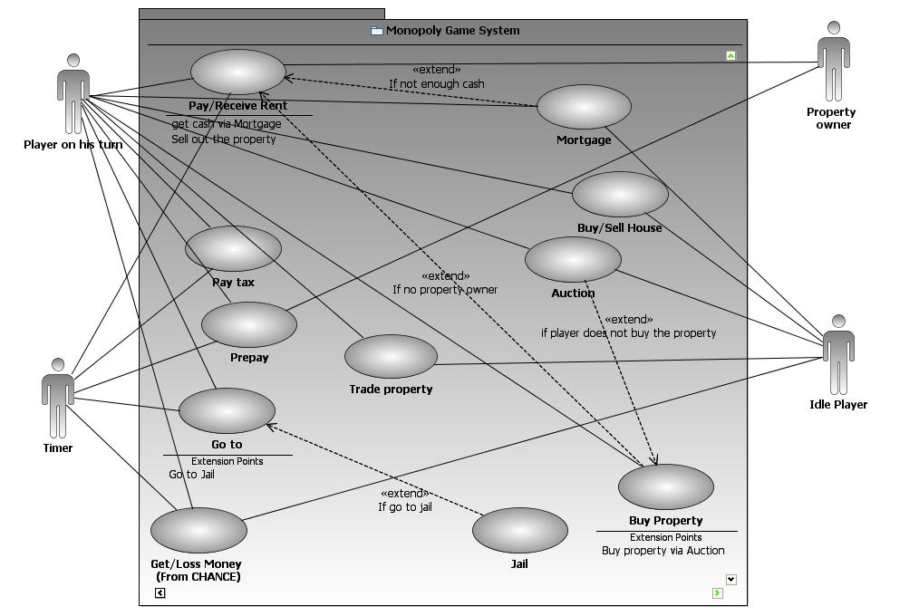
Figure 1: Design Use Case Model

The design use case diagram is built on the analysis use case diagram in the OOA report.
When doing the OOD report, we have reviewed the use case diagram again. No new actor or use case has been added to the use case diagram, as we have thought and discussed deeply what use cases and what actors are include in the OOA stage. So, all the use cases in the diagram are enough to cover all the actions that the system should include.
Table 3. Use Case Summary
Use Case | Analysis Use Case | Description
UC1-D1: Pay/Receive Rent | UC1 | To pay or receive rent
UC2-D1: Buy Property | UC2 | To buy property which is not owned
UC3-D1: Mortgage | UC3 | To mortgage property to get cash
UC4-D1: Go to ... | UC4 | To move player’s token
UC5-D1: Jail | UC5 | To stop player’s turn 3 rounds unless player pay fine.
UC6-D1: Trade Property | UC6 | To trade property with other player
UC7-D1: Get/Loss Money (from CHANCE) | UC7 | To give or get cash from player
UC8-D1: Buy/Sell House | UC8 | To build house on property to receive more rent
UC9-D1: Pay Tax | UC9 | To deduct player’s cash
UC10-D1: Auction | UC10 | To auction a property to highest bidder
UC11-D1: Prepay | UC11 | To let player prevent from paying all rent

Design Philosophy
Our design principle is to make an easy-to-use system. The monopoly is indeed an exciting game, except for trivial calculation of cash that have to pay and the storage problem of the paper cash. So, we focus on the making a high usability system, which most operations are done automatically by the system, which makes plays be more convenient in playing monopoly with our system.
Our main design philosophy is easily to use and high usability. To attain high usability, the main point is to standardize the mouse click sequence of user. You can see that from the 3 use cases mentioned above, the mouse click sequence is nearly the same. The sequence is mentioned below.
First, the action window is displayed on screen and waiting for user to select action.
Second, the action window display the information required for the use case.
Third, the user makes decision and press [OK].
Finally, the window refreshes and updates the information to display on screen.
With standardizing the sequence of mouse clicked, user can easily finish the task they wanted. That satisfies our design philosophy, high usability, convenient and easy to use.

Transforming to “Design” Use Cases

Use Case 1 - Description 1: pay/received rent

First, we assume that the timer hasn’t time out.

In this use case Pay/Receive Rent, the procedures are started when the player arrives the land. The system will validate the land belongs to which types of property/utility/station and validates it is owned or not by using OWNER of the property. If the PROPERTY is owned by nobody, invoke buy property use case. If the land belongs to property/utility/station, the system validates the land is mortgaged or not through MORTGAGE STATUS. If the land is not mortgaged, the system validates the player has prepaid or not through Prepay rent class. If the player has not prepaid, the system calculates the rent amount and validate that the player have enough CASH. It will update the changes of the involved players.

The use case ends when the land does not belong to property/utility/station, the land is mortgaged, the player has prepaid and the system finishes the pay or receives rent process.

Table 4. Use Case 1: Pay/received rent
Primary Actor: Player on his turn
Stakeholders and Interests
-Player: no payment errors
Preconditions:
-Player has enough money
Success Guarantee (post-conditions):
- Payment is correctly calculated
-Bank accounting updated
Main Success Scenario
Actor Action(or Intention) | System Responsibility
Now, the system is now displaying wealth and property window, map window.

1. When it comes to player’s turn, an action window is currently displayed on screen waiting for the user to select an action.
2. When the player wants to move, then he/she needs to indicate by pressing the [roll dice] button.
 | 3. The system randomly generate a number between 2 to 12.The system displays the number on the map window to show the steps.
 | 4. The system calculates the new LOCATION by adding the generated number and then refresh the location of player’s token in the map window.
 | 5. The system validates the land belongs to which TYPE of property/utility/station and validates it is owned or not by using OWNER of the property.
 | 6. The system validates the land is mortgaged or not through MORTGAGE STATUS.
 | 7. The system validates the player has prepaid or not through LOCATION and PLAYER of the Prepay rent classes together.
 | 8. The system calculates the rent amount by using RENT, COLOR, NUMBER OF BUILDING, and NUMBER OF HOTEL and show the pay rent information to the Player in the Action window..
9. Player presses [OK] button.
 | 10.The system validates that the player have enough CASH
 | 11. The system deducts player’s CASH and adds the property owner’s CASH, then updates the involved players’ WEALTH.
 | 12. The system refreshes wealth and property window and show to players.
 | 13. The system finishes the pay or receive rent process, and then it refreshes the action window to allow player to continue other actions.

Table 5. The Alternative Course of Events for UC1: Pay or receive rent
Alternative Course of Events (Alternative Flow)
Step 5a: If the PROPERTY is owned by nobody, invoke buy property use case.
Step 5b: If the land does not belong to property/utility/station, go to Step 13.
Step 6: If the land is mortgaged, go to Step 13.
Step 7: If the player has prepaid, go to Step 13.
Step 10: If not enough CASH, invoke mortgage use case, then go to Step 11.

Use Case 2-Description : Buy Property

This is a design use case of buying property. The goal of the use case is to build up a fair transaction between player and banker (system) so that the player can pay enough money to buy their property. To achieve this, we have to first build up a system with several clear steps.
Before running the buy property system, we assume that the timer hasn’t timeout. The system will run the following steps which are also in the use case. In the beginning, there is a wealth and property window which shows the wealth and property of all players. The information disclosure avoids the treating of player. Then action window will be displayed to let the player of that round to roll dice. After that the system will generate the random number of two dice and show the number on map window. It let the players to know what the result is. The system will then add the number of player location and show it on map window. It is important that for the system to memorize the current user location. Then the system will do two validations. One is to find out the type of land of that player’s location. Another is to check if it has owner. It is important to determine what use case the player is going to run.
If there is a owner, invoke pay/receive rent use case. If the land does not belong to property/utility/station, go to Step 13.
If there are no owners, the buy property operation will be invoked. The system will retrieve the information of land and display on the action window. The player can choose buy or not. If he doesn’t buy, it invokes the auction use case. If he buys, system will calculate if he has enough cash to ensure he can afford the property. This validation is important to ensure all players will have a fair game. If he doesn’t have enough cash, auction case will also be invoked. If he has enough cash, the system will deduct the player’s cash and update the wealth by assigning the property to that player. The system will refresh the wealth and property window because the data of players have been changed. So all the player will know what happened. The action window will be refreshed finally to process other action.

Table 6. Use Case 2: Buy property
Primary Actor: Player on his turn
Stakeholders and Interests
-Player: no payment errors
Preconditions:
-Player has enough money
-Property haven’t got owner
Success Guarantee (post-conditions):
- Payment is correctly calculated
-Bank accounting updated
-Property ownership recorded
Main Success Scenario
Actor Action(or Intention) | System Responsibility
Now, the system is now displaying wealth and property window, map window.

1. When it comes to player’s turn, an action window is currently displayed on screen waiting for the user to select an action.
2. When the player wants to move, then he/she needs to indicate by pressing the [roll dice] button.
 | 3. The system process the action, randomly generate a number between 2 to 12.The system displays the number on the map window to show the steps.
 | 4. The system calculates the new LOCATION by adding the generated number, and then refresh the location of player’s token in the map window.
 | 5. The system validates the land belongs to which TYPE of property/utility/station and validates it is owned or not by using OWNER of the property.
 | 6. The system retrieves the PRICE, RENT and COLOR of the property and displays them on the Action window.
 | 7. The system displays the buy or skips option on the Action window.
8. Player presses [buy] button.
 | 9.The system validates that the player have enough CASH
 | 10. The system deducts player’s CASH and updates the player’s WEALTH.
 | 11. The system refreshes wealth and property window and show to players.
 | 12. The system finishes the buy property process, and then it refreshes the action window to allow player to continue other actions.

Table 7. The Alternative Course of Events for UC2: Buy property
Alternative Course of Events (Alternative Flow)
Step 5a: If the PROPERTY is owned by somebody, invoke pay/receive use case.
Step 5b: If the land does not belong to property/utility/station, go to Step 12.
Step 7: If player signals to the system not to buy the property, invoke use case Auction.
Step 9: If the system validates that the player haven’t get enough CASH invoke use case Mortgage

Use Case 11: Prepay Rent

Prepaid rent is the design use case for transferring the prepay rent value, showing prepay value.

This is a design use case of prepaid rent. The main target of the use case is to show the prepay rent for different players, and transfer the prepay value, after that we should keep a record for use case pay rent.
As the same for other use case, before running the buy property system, we assume that the timer hasn’t timeout. As default, there are map window and wealth and property window to show the map information and to show the wealth of the users respectively. After entering the player’s turn, the action window will be displayed to let the player to select action. In this use case, the user will select prepay action. After that the system will retrieve the information of player and land. And then, the system will calculate the prepay value of each other players and display on screen. The system allows the player to choose prepay target. Right after that, the system will validate player have enough cash or not. If yes, the system will then make the transaction between two players. The system will log the transaction.
Table 8. Use Case 11: Prepay rent
Primary Actor: Player on his turn
Stakeholders and Interests
-Player: no payment errors
Preconditions:
-Player has enough money
-The target user has property within the next 12 steps of player.

Success Guarantee (post-conditions):
- Payment is correctly calculated
- Bank accounting updated
- Player only pays half of the rent if he/she arrived target property.
Main Success Scenario
Actor Action(or Intention) | System Responsibility
Now, the system is now displaying wealth and property window, map window and action window.

1. When it comes to player’s turn, an action window with different options is currently displayed on screen waiting for the user to select an action.
2. When the player wants to prepay for the target user, then he/she needs to initiate the use case by pressing the [prepay] button.
3. The system retrieves highest RENT of next 12 steps property of each player.

Then, the system calculates each the PREPAY VALUE of each player.

The system refreshes the action window to display the name of OWNER and PREPAY VALUE.
4. The player indicated the target owner by pressing the [button with name].
 | 5.The system validates that the player have enough CASH
 | 6. The system deducts the player’s CASH and transfer the amount by increasing the target player’s CASH.
 | 7. The system log this prepay event in LOCATION and PLAYER in the prepay rent classes.
 | 8. The system refreshes the action window. And let player to continue other actions.

Table 9. The Alternative Course of Events for UC11: Prepay Rent
Alternative Course of Events (Alternative Flow)
Step 5: If the player do not have enough CASH to prepay, invoke “mortgage” use case.

Getting Consensus on Design Philosophy
After a number of discussions, and argument, we have a common consensus of listed actors, listed designed used cases and their detail. We build up the flow of how systems run, so that we know what is the relationship of the use case and how to invoke each use case in the use case scenario.
For the listed actors, we have considered the interaction of the actor with the system, invoke the functions and receive output. We make sure the actor will not be a part of the system. So we have already removed banker as an actor in the OOA stage.
For the listed designed use case, we have discussed a detail flow of each case and make a decision of the common name which we will use in all use case. Also, we have discussed how the common steps such as throw dice and pay money works. So, after the discussion, we have a consistent flow in the common steps.
Furthermore, we have also talk about the class we used in design class diagram, we all use same class name and make the diagram more consistent.

MODELING OBJECT BEHAVIORS

OOA Class Diagram
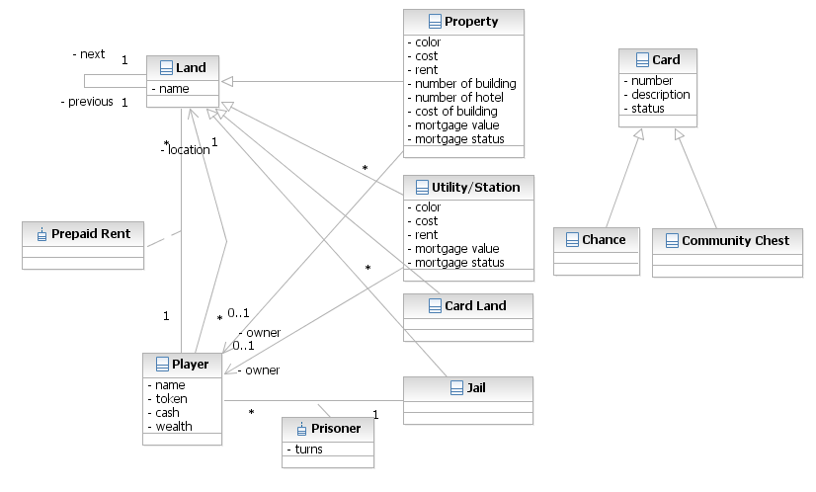
Figure 2: Class Diagram from OOA report
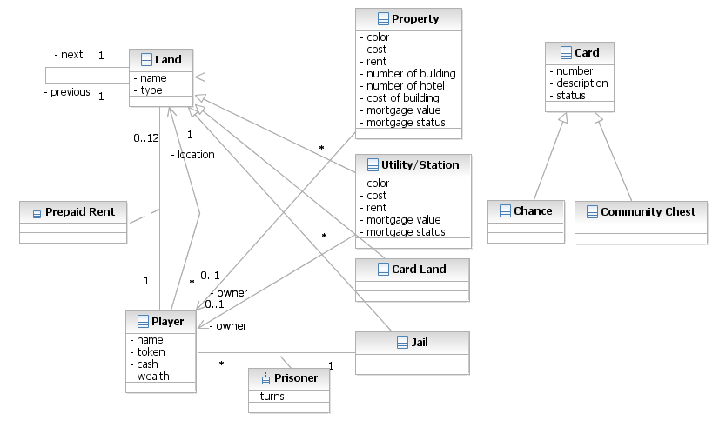
Figure 3: Revised Class Diagram

According to the opinions from peer students and our discussion, the analysis class diagram already shows all the key features of the monopoly game system to be modeled, so that it is quite well and no need to create additional class. We only add one attribute "type" in class "Land" for distinguishing the type of land from "Land" more easily. The class relationship is appropriate such that the flow of scenarios of each use case can be applied to the class diagram. In class "Prepaid Rent", the multiplicity of "Land" is modified as "0..12" from "*" because the class "Prepay Rent" stores further 12 locations only.

Design Classes
From the use case specifications, we highlighted the important nouns and we examined all of them. By the heuristic method, the following boundary classes, control classes and the entity classes are found.

Table 10. Design Class Categorization
Boundary class | Control class | Entity class
Action Window (uc1,2,11) | Prepaid Controller(uc11) | Land
Wealth and Property Window (uc1,2,11) | Roll and Move Controller(uc1,2,11) | Player
Map Window (uc1,2) | Action Controller(uc1,2,11) | Property
 | Rent Controller(uc1) | Prepay Rent
 | Buy Property Controller (uc2)

The following part will mainly focus on why does the design classes exists in our design.

Since, nearly all of three boundary classes are used to present data in all of our use cases, it is important for us to clarify the use of the boundary classes first.

In order to attain ISP, the main graphical user interface window is divided into 3 parts which are action window, wealth and property window and map window. Action window is for taking all the input by players. Wealth and property window is for showing the status of players such as the cash, property owning. Map window is used to show the token of player and the number of dice rolled.
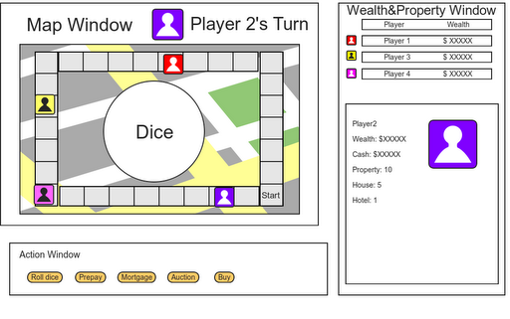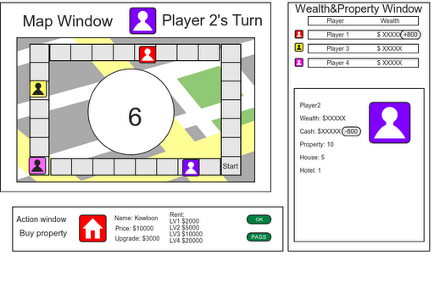
Figure 4.1 Figure 4.2

Action window (for use case 1, 2 , 11)
The Action window is the boundary class that responsible for displaying different action options. (Refer to figure 3.2.1) It is also responsible for receiving the request of the user.
Once the user decided the action, the action window will change and display different contents. For example, if user decided to buy property, the action window will change and display the information of the target property.
Justification:
Originally, our design is separate different action options displayed in different pop-up windows. Therefore, we had a lot of boundary classes in previous design.
However, following the coupling and cohesion principle, we found that the previous design is too loosely, each class only used to display one item and can’t be reused. So we change our design to this with high cohesion and coupling.

Wealth and Property Window (for use case 1, 2, 11)
The Wealth and Property Window is the boundary class that responsible for displaying the current wealth and cash of each user, also it will display all the information of user, such as, property, house, etc.
It is not used to receive any inputs of the user. It is a boundary class that retrieves the data in the system and displays them to the user.
The most important work of this boundary class is handling the refresh wealth and property of all users (for UC 1, 2, 11), I will explain further below.

Map Window (for use case 1, 2)
The Map Window is the boundary class that responsible for displaying the location of each player, different properties in the map and the roll dice result.
Same as the Wealth and Property Window, its main responsibility is only handling the movement of the tokens of the users. It will not receive any input from the user.

Action Controller (for use case 1, 2, 11)
Action Controller is a control class which directs the user input to suitable control class to continue the operation. The reason to have Action Controller class is because we want to have a functional cohesion design, that’s a class should take up more than one task. When the request passed to Action Controller, it will further divide the labor to different classes but not finish all the processing in one class.

Roll And Move Controller (for use case 1, 2, 11)
Roll And Move Controller is a control class to generate roll dice result and update the location of user’s token. The reason to have Roll and Move Controller is because it is also a part of the use case step (and even in other use case). Though there are only few operations in the Roll and Move Controller, again, due to cohesion problem, we divide it as a control class.

Rent Controller (for use case 1)
Rent Controller is used to calculate the rent payment and make the transaction complete.

Buy Property Controller (for use case 2)
Buy Property Controller is used to control the transaction of property and cash of user. As mention above, we decided to have a single control class for each function to attain high cohesion.

Prepay Controller (for use case 11)
Prepay Controller is used to find prepay value, transaction of prepay rent. As mention above, we decided to have a single control class for each function to attain high cohesion.

Previously, we decided to have a bank account controller class to handle all of the transaction of buy property, prepay and pay rent, it seems that it is easy to control and easy to design.
However, by considering cohesion principle, we found that the bank account controller takes up a lot of jobs and it is not a good practice. So, finally, we decided to break the bank account controller to pay rent, buy property, prepay controller.

Additional Attributes
In OOA, we have identified many classes and attributes. There is only one attribute added because we have identified most of the attributes in OOA report. The additional attribute is TYPE. We have not identified the types of land in OOA report and now we add it in OOD report because we find it is crucial to be included. It is a string that stores the type of land, namely property, chance/community chest, card land and jail. The attribute belongs to the class LAND.

Table 11. Attribute List
Attribute | Description | Belonging Class in the Domain Model
type | A string that store the type of land, namely property, chance/community chest, card land, jail. | Land

Model High-Level Object Interactions

Before we came up with this communication diagram, we have followed some design guidelines. First, we transformed the analysis use cases to design use case. Then, we identified design classes (boundary, control and entity) and attributes. Finally, we sketched the communication diagram.

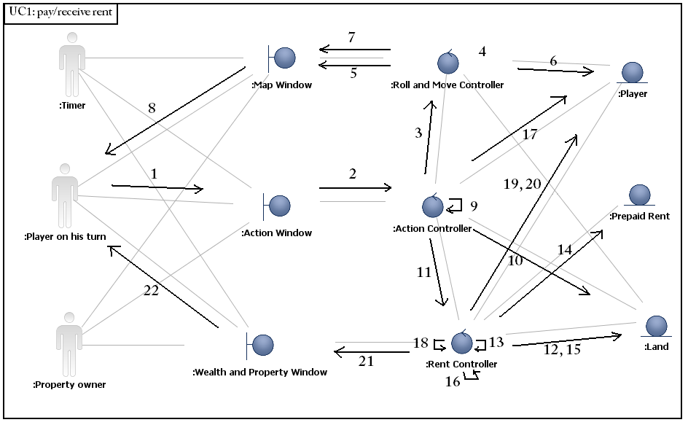
Figure 5. Communication Diagram for UC1-D1 (Pay/Receive rent)

1. Calls to Action Window.
2. Calls the Action Controller.
3. Calls the Roll and Move Controller.
4. Generates random numbers of the dice.
5. Displays the random numbers of the dice to the Map Window.
6. Updates the location of player in Entity Class Player.
7. Refreshes the Map Window.
8. Displays updated Map Window details.
9. Validates the ownership of the Land.
10. Gets the types of Land and uses the Type to get ownership.
11. Calls Rent Controller.
12. Gets Land.
13. Validates mortgage status.
14. Gets chosen player and land to validate prepaid.
15. Gets land information.
16. Makes calculation.
17. Gets cash information.
18. Validates enough cash.
19. Updates the cash of player on his turn and property owner.
20. Updates wealth.
21. Refreshes the Wealth and Property Window.
22. Displays updated Wealth and Property Window details.
The communication diagram demonstrated the steps of wealth transfer when the player arrives at a land.

Firstly, the system will display the map to the player through the Map Window. When the player roll the dice, the Action Window will be activated and call the Action Controller. Action Controller will then call the methods in Roll & move controller.

The token of the player will be moved to the correct location. If the player arrives at the Property, Utility, Station, Rent Controller will be activated and get information of entity classes, namely Property, Utility, Station and Player. Afterwards, the system will show these information to the player and the property owner throng the Wealth and Property Window.

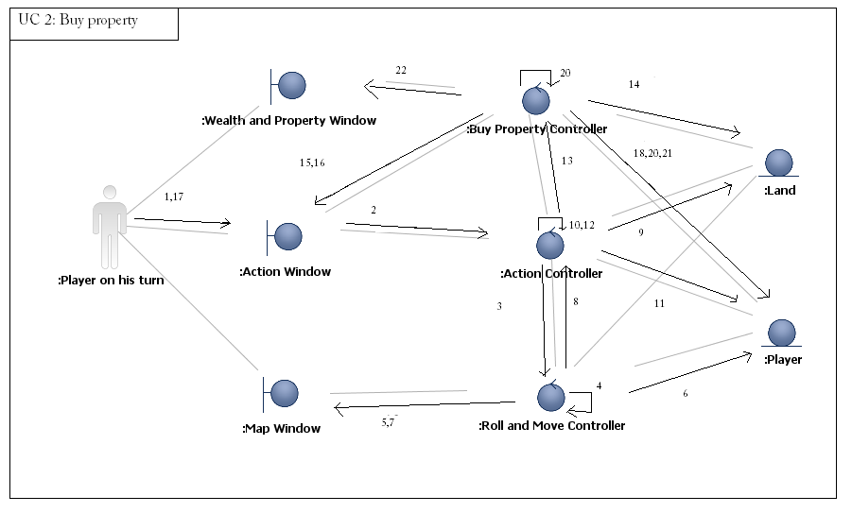
Figure 6. Communication Diagram for UC2-D1( Buy property)

1. Press the [roll dice] button
2. Process the roll and move
3. Process roll and move controller
4. Generate a number between 2 to 12
5. Display the number on the map window
6. Calculate the new location
7. Refresh the new location of the player
8. Process the action
9. Get the type of land
10. Validate the land type
11. Get the owner
12. Validate it is owned or not by using owner
13. Call the process of buy property controller
14. Retrieve land information
15. Display property data on action window
16. Display the buy and skip functions
17. Press [buy] button
18. Get the cash of the player
19. Validate the player have enough cash
20. Deducts player’s cash
21. Update the player’s wealth
22. Refresh wealth and property window

The communication diagram demonstrated the steps to take when a player buy the property.

When it is the player’s turn, the Action Window will display the option to the player. The player select the roll dice then the Action Window will signal the Action Controller to process roll dice. The Action Controller calls the Roll & Move Controller to process movement. The Roll and Move Controller will first generate a random number from 2 to 12 and send to Map Window to display it. Then the Roll and Move Controller will send the number to Player and update the location. The Roll and Move Controller will call the Map Window again to display the chess movement. After the movement, the Action Controller will get the location and validate the type of land. If the land is property/Utility/Station, it will validate does the land have owner or not. If there is no owner Action Controller will call the Buy Property Controller to process buying property. The Buy Property Controller first get the Player‘s location, then get the Land’s information. The information will pass to the Action Window and display it. The player press the buy button in Action Window will signal the Buy Property Controller to process. The Buy Property Controller will get the amount of cash from Player and validate enough cash or not. If it is enough, Buy Property Controller will send the amount to player to update the cash and wealth. The Buy Property Controller finally will call the Wealth and Property Window refresh.

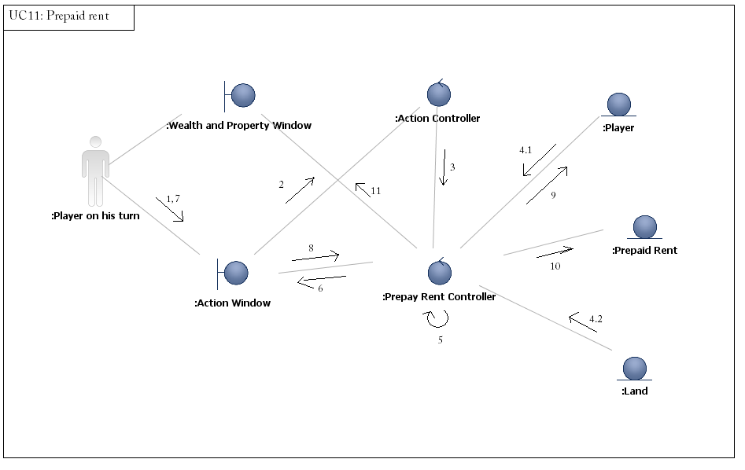
Figure 7. Communication Diagram for UC11-D1( Prepay rent)

1. Pressing [Prepay] button
2. Request Action controller
3. Request Prepay Rent Controller
4.1 Retrieve player’s information
4.2 Retrieve land information
5. Calculate prepay value.
6. Show the prepay value of different players on action window
7. Player indicate which other player he is going to prepay to
8. Action window pass the data to prepay rent controller
9. Update players’ wealth and cash
10. Record the prepay event.

The communication diagram shows the steps when the player prepay rent in his turn.

When the player press the [prepay bottom] in the Action Window. The request will be sent to the Action controller, which it will then send to the Prepay Controller. Then Prepay Controller retrieve data from Land and Player, then calculates the amounts which have to pay for prepaying other players and show in the Action Window. Player chooses which other player he is going to prepay and send this indication to prepay controller. Cash was transferred and Player information is updated. This prepay entry is then recorded in prepay rent. Lastly the Wealth and Property Window updates the cash of players.

Class Behaviors and Responsibility
Philosophy of allocating behavior to different classes
In order to form a good object-oriented design class diagram, we have to separate the roles of different class type. For the boundary class, they are only responsible to receive input decision from the actor, display and refresh the data which is supposed to be there. Besides, all validation method are done by control class for two reason: firstly is encapsulation, we think that all the data in entity class should be encapsulated which the private data will not be modified externally; secondly, since sometimes the program will take the data from two entity classes to validate, it will be done on control class. Furthermore, if we change to data directly, the program will do it on entity class.
Our OO class has applied two principles which are LSP (Liskov Substitution Principle) and ISP (Interface Segregation Principle). For LSP, we have a superclass Land and two subclasses which are Property and Utility/Station. Those subclasses are different type of land but they have different attributes such as Property have building. Those subclasses are substitutable for the superclass and they have common attributes such as name and type. For the ISP, we do not allow one interface to take too many responsibilities. We have 3 boundary classes which are Map window, Action window and Wealth and Property window to handle different actions.

Use Case 1: pay/received rent

The only manual action in this use case is the process when the player presses the [roll dice] button. The boundary classes are the action of displaying the information of the game. There are three control classes which are responsible for processing the rolling and moving, action of player, pay and receive rent processing. They coordinate the actions between the boundary and the entity classes. Any retrieving or updating of land and player attributes are regarded as the entity class.

Table 12. Use Case 1: Pay/received rent

Behaviors | Automated or Manual | Design Class Type | OO Class Responsible | Proposed Method Name
validates the land belongs to which types of property/utility/station | A | Control | Action Controller | process
validates the land is owned or not | A | Control | Action Controller | ownership
validates the land is mortgaged or not | A | Control | Rent Controller | validate_mortgaged
validates the player has prepaid or not | A | Control | Rent Controller | validate_prepaid
calculates the rent amount | A | Control | Rent Controller | calculation
Adds/deducts player’s CASH | A | Entity | Player | transfer_cash
updates the involved players’ WEALTH | A | Entity | Player | update_wealth
process action | A | Control | Action Controller | process
process action | A | Control | Rent Controller | process
refreshes wealth & property window | A | Boundary | Wealth and property window | refresh
refresh the action window to allow player to continue other actions | A | Boundary | Action Window | refresh
retrieve land information | A | Entity | Land | get_land
validates that the player have enough CASH | A | Control | Rent Controller | validate_cash
retrieve the CASH of player | A | Entity | Player | get_cash
display wealth and property window | A | Boundary | Wealth and property window | display
display map window | A | Boundary | Map Window | display
display action window | A | Boundary | Action Window | display
press the [roll dice] button | M
process [roll dice] | A | Control | Roll and Move Controller | process
update the new LOCATION | A | Entity | Player | update_location
refresh the location of player’s token | A | Boundary | Map Window | refresh

Use Case 2: Buy property
The manual action of this use case is the press roll dice and press buy button. There are three boundary classes which are Map Window, Action Window and Wealth and Property Window. Map Window is used to display the player token and the whole map in the screen. Action Window is used to provide the current action that you can choose. Wealth and Property Window is used to show all the wealth and property owned of all players. There are three control classes (Roll and Move controller, action controller and buy property controller) which are responsible for roll dice, determine what action to be token, validation and calculation through the transaction processing. They coordinate the actions between the boundary and the entity classes. There are two entity classes which are player and land. And land will have two subclasses which are property and utility/station. And the corresponding OO class of each action is derived from the communication diagram.

Table 13. Use Case 2: Buy property

Behavior | Automated or Manual | Design Class Type | Responsible | Method name
1.An action window is currently display on the screen | A | Boundary class | Action Window | display
2. Press the [roll dice] button | M
3.Process the roll and move | A | Control class | Action Controller | process
4.Process roll and move controller | A | Control class | Roll and Move Controller | process
5.generate a number between 2 to 12 | A | Control class | Roll and Move Controller | genRandom
6. Display the number on the map window | A | Boundary class | Map Window | display
7. Calculate the new location | A | Entity class | Player | getLocation
8. Refresh the new location of the player | A | Boundary class | Map Window | refresh
9.Get the type of land | A | Entity class | Land | get_type
10. Validate the land belongs type | A | Control class | Action Controller | process
11.Get the owner | A | Entity class | Property/Utility/Station | get_owner
12.Validate it is owned or not by using owner | A | Control class | Action Controller | ownership
13.Call the process of buy property controller | A | Control class | Buy Property Controller | process
14.Retrieve land information | A | Entity class | Land | get_land
15.Display property data on action window | A | Boundary class | Action Window | display
16.Display the buy and skip function | A | Boundary class | Action Window | display
17.Press [buy] button | M
18.Get the cash of the player | A | Entity class | Player | get_cash
19. Validate the player have enough cash | A | Control class | Buy Property Controller | validate_cash
20. Deducts player’s cash | A | Entity class | Player | transfer_cash
21.Update the player’s wealth | A | Entity class | Player | update_wealth
22. Update the property owner | A | Entity class | Property/Utility/Station | set_owner
23. Refresh wealth and property window | A | Boundary class | Wealth and Property Window | refresh

Use case 11: prepayment
The manual action in this use case is the press the prepay button and indicate which other player that the player on his turn is going to prepay.
The displaying of action that can choose, wealth status and the map is handled by boundary class. There are two control classes which are responsible for processing player’s action input and process prepay rent operations such as retrieving Land’s rent and record prepayment. They coordinate the actions between the boundary and the entity classes. Any retrieving or updating of Land, Player, Prepaid rent attributes are regarded as the entity class.

Table 14. Use Case 11: Prepay Rent
Behaviors | Automated or Manual | Design Class Type | OO Class Responsible | Proposed Method Name
1.An action window is currently display on the screen | A | Boundary | Action window | display
Press the [Prepay] button | M
Process prepay rent | A | Control | Prepay Controller | process
Get property rent | A | Entity | Land | get_rent
Calculate each the PREPAY VALUE of each player | A | Control | Prepay Controller | cal_prepay_value
Refreshes the action window to display the name of OWNER and PREPAY VALUE. | A | Boundary | Action Window | refresh
Indicated the target owner by pressing the [button with name]. | M
Validates that the player have enough CASH | A | Control | Prepay controller | validate_cash
Adds/Deducts player’s cash | A | Entity | Player | transfer_cash
System logs the prepay event | A | Entity | Prepaid Rent | player  location
Retrieve the CASH of player | A | Entity | Player | get_cash

Dynamic Modeling
This sequence diagram is consistent with class diagram and communication diagram. It is mainly centralized because the order of operations can be changed and it is easy to insert new operations when there is a need to add new functions or have more validations.

For the role of variables, rent controller is a follower. Its values, which are player’s and land’s id, passing to entity classes to get information follow the values obtained from Action Controller.

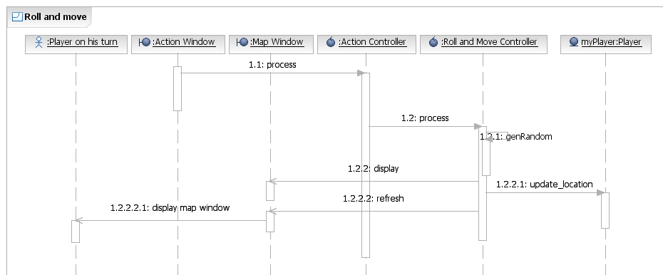

Figure 8: Sequence diagram of Roll and Move [1]

Description of Roll and Move
This sequence diagram supports the Roll and Move use case. The Roll and Move process is started when the player presses [roll dice] button or out of time. The Action Controller will call Roll and Move Controller to generate a random number to indicate the new location. After that, the location of the player will be updated. Finally, Roll and Move Controller will refresh the Map Window and the refreshed information will be shown.

UC1: Pay/Receive Rent
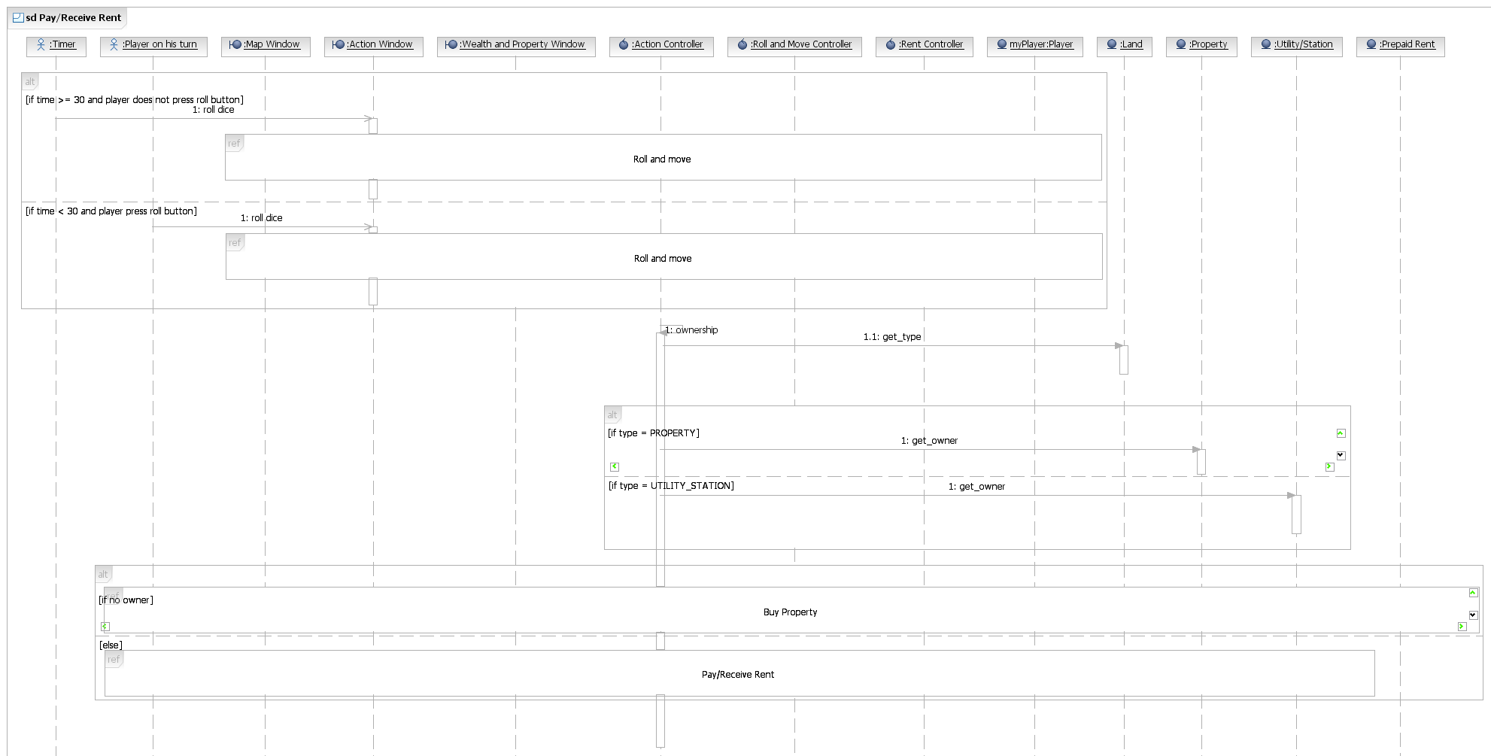
Figure 9.1: Sequence diagram of Use Case 1(Pay/Receive rent) [2]

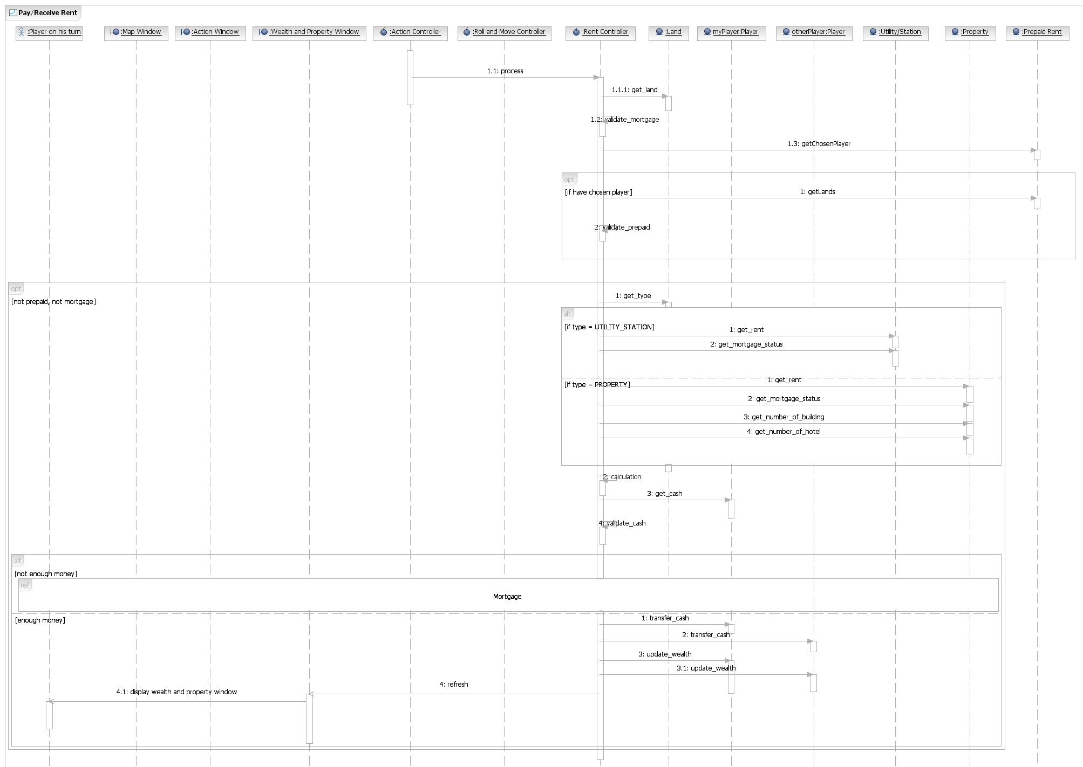
Figure 9.2: Sequence diagram of Use Case 1(Pay/Receive rent) [3]

Description of SD01 of UC1: Pay/Receive Rent
This sequence diagram supports the use case UC1 – pay or receives rent. The pay or receive rent process is started when the player presses [roll dice] button and arrives the land which has an owner. The pay and receive rent process will be aborted if the land is mortgaged or the player has prepaid. If not, the validation (check if the player has enough CASH) will be processed. If the validation succeeds, the WEALTH of involved players will be updated. Finally, the refreshed information of players will be shown on the screen and the system allows the player continues other actions.
UC2: Buy Property
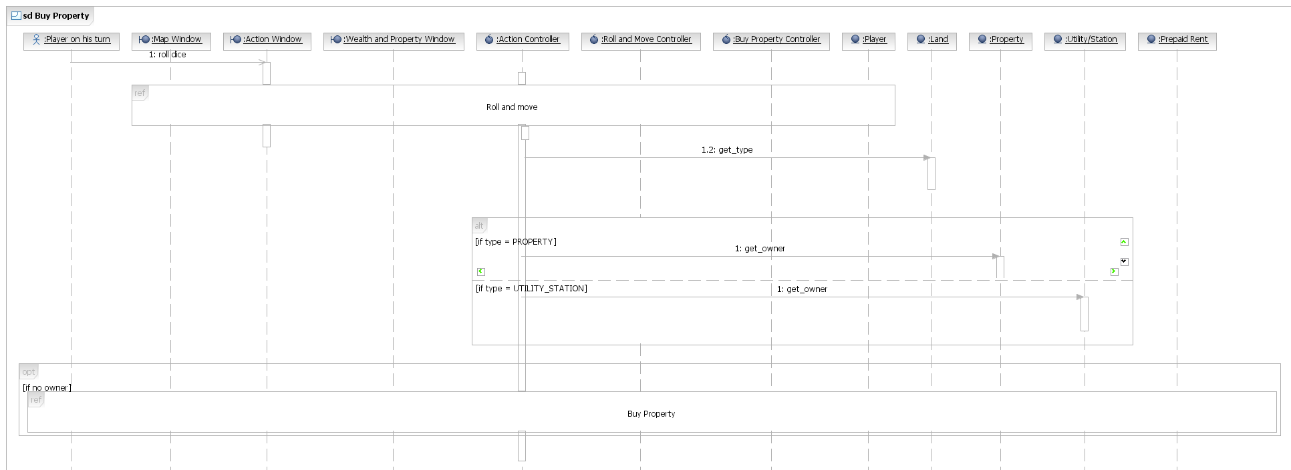
Figure 10.1: Sequence diagram of Use Case 2(Buy property) [4]
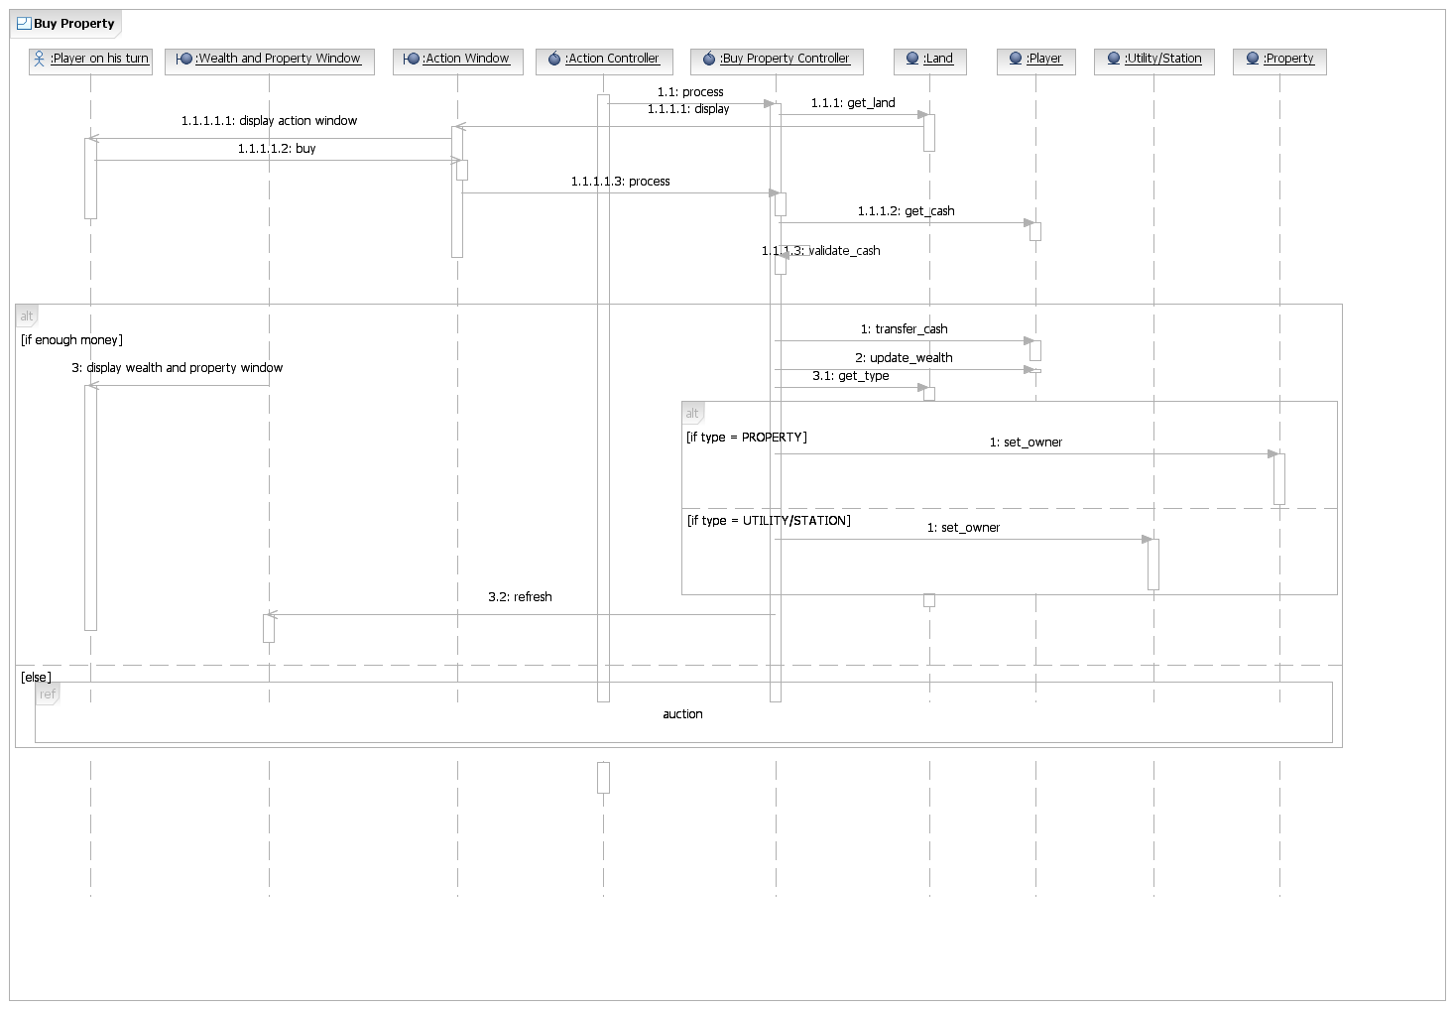
Figure 10.2: Sequence diagram of Use Case 2(Buy property) [5]

Description of SD02 of UC2: Buy Property
To perform the buy property process, the Action Controller will call the Buy Property Controller to begin the use case. Firstly, Buy Property Controller will ask Land to get the information include color, cost, rent mortgage value. The information will pass to Action Window and display to the Player. The Player will reply the opinion buy or not. If the player does not buy the property, then the system will invoke the Auction Use Case. Else, the Buy Property Controller will get the amount of cash from the Player and validate is the player have enough money or not. If the player enough money, the Buy Property Controller will send the amount to the Player and deduct the cash and wealth. Finally the Buy Property Controller calls the Wealth and Property Window to refresh the window and display to player. If the player doesn’t have enough money, the system will invoke the Auction Use Case.
UC 11: Prepay Rent
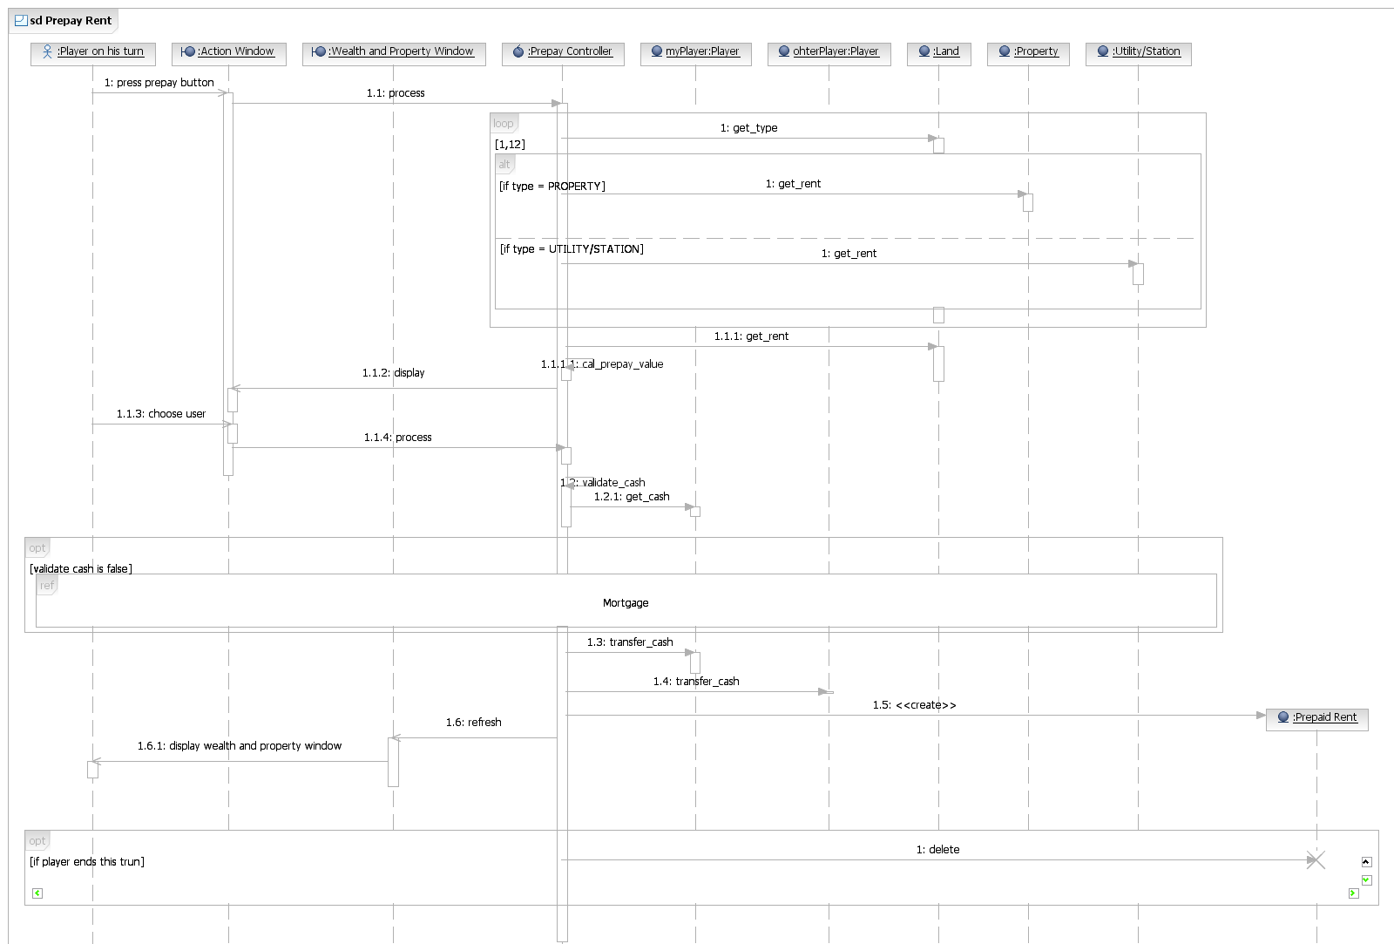
Figure 11: Sequence diagram of Use Case 11(Prepay Rent) [6]

Description of SD03 of UC11: Prepay Rent

First, after the user press prepay button. The action window will call the prepay controller to work.
The prepay controller will get the rent of property in the next 12 steps of player to calculate the prepay value. In order to get the rent of each property, here, we will use loop combined fragment to retrieve the rent of each property.

“Originally, we decided to have one function to get all the rent out. However, we cannot reuse that get rent function to get the rent of single property, it is not a good design. Then, we change to loop 12 times of get the rent of single property, the function can be reused by other use case.”

Also, some of the land may not be the property. So we will use option combined fragment here for making decision.

After that the rent will be used to calculate the prepay value. Then, return the prepay value of each player to the action window to let the user to make decision.

The action window will receive the input of user, and call the prepay controller to process again. Then, prepay controller will validate that the user have enough cash to prepay. If not, the system will invoke the SD Mortgage.
If the user have in enough cash, the system will continue to transfer the prepay rent.

Once again, we decided to have one function to transfer the cash and receive the cash. However, we cannot reuse that transfer rent function. Finally, we decided to separate the add rent and deduct rent will 2 different methods.

Design Class Diagram
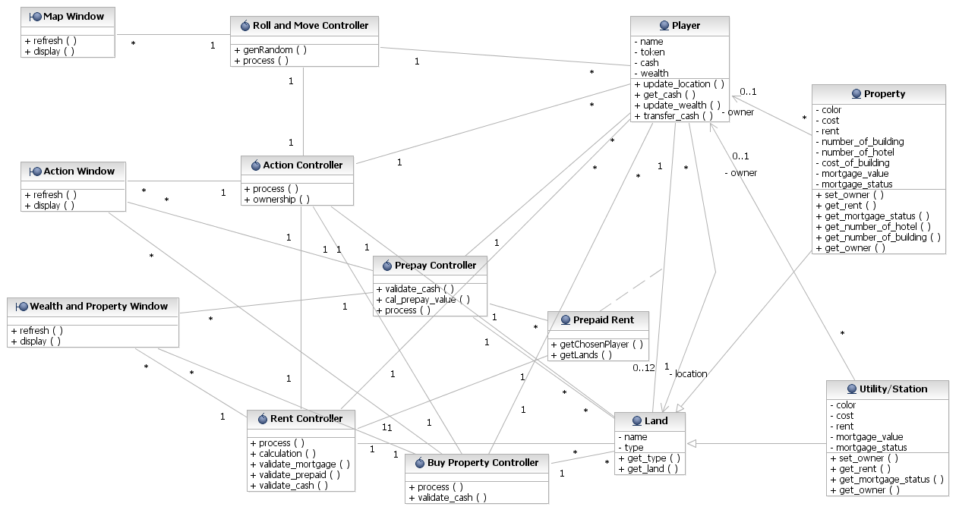
Figure 12: Design Class diagram
Our design class diagram tries to model the system in a more comprehensive way. There are three kinds of class – boundary class, control class and entity class. Boundary classes communicate with actors. They are Map Window, Action Window and Wealth and Property Window. Control classes control and coordinate boundary classes and entity classes in the system. They are Roll & Move controller, Action Controller, Rent Controller, Buy Property Controller and Prepaid Controller. Finally, entity classes, including Player, Land, Property, Prepaid Rent and Utility/Station, keep the application data of the system.

The analysis class diagram only has entity classes. However, in the design class diagram, boundary classes and control classes are added so as to improve the efficiency of class management and divide functions of different classes more clearly. Also, some new methods and attribute are added to the design class diagram.
Table 15. Class description
Class description
Class Type | Class Name | Description
Boundary | Action Window | Window for player to perform actions
Boundary | Wealth & Property Window | Window for displaying players’ wealth and property
Boundary | Map Window | Window for displaying the map
Control | Prepaid Controller | Processing prepay
Control | Roll & Move Controller | Processing Roll & Move
Control | Action Controller | Processing action
Control | Rent Controller | Processing pay or receive rent functions
Control | Buy Property Controller | Processing buy property functions
Entity | Land | Store the information of lands
Entity | Player | Store the information of players
Entity | Property | Store the information of properties
Entity | Prepay Rent | Record players have prepaid or not

REFLECTION
After working on this project, we have a better understanding of the procedure of the software design. According to the OOD process, we have made the design use cases, the communication diagrams, the sequence diagrams and the final class diagram. Besides, additional attribute is added. Firstly, we finish the design use cases and have a detailed scenario of each use case. Then, we find out the additional attribute, methods, and draw a diagram to show the behavior and responsibility. Afterwards, we try to work out the communication diagram of each use case. Then, we can draw an updated class diagrams with new objects. Finally, we work out the sequence diagram of each use case.
Communication among team members is enough. To work out the OOD report, we have had group meetings twice a week since the release of the assignment. Although there were some arguments during the discussion, we finally overcame with the problems and got consensus. Division of labor is greatly applied in our team. Two people per group which is responsible for doing the design use case and one person is responsible for sketching the diagram. The remaining parts of the OOD report are evenly distributed to each team member.

For ethics concerns, our system will be free of charge which everyone is able to enjoy our software, the income that we earn may come from advertisement inside the software.
Free update will be provided as to best meet the client’s interest.
The system is run independently; no pre-installation of other software is required.
Sufficient test will be executed before the release of the system in order to fix as many bugs as possible. Future update is also provided.
During the whole process, all teammates are fair and supportive to other teammates. We also maintain integrity and independence when having judgment.

SUMMARY
During the process of making OOD report, we overcame many problems.
The first one needed to be mentioned is identifying the relationship among the classes. Originally, we added the Bank Controller for calculating the wealth transfer. But we finally deleted it because this can be done by using other controllers to call the function of entity class.
During the process, we found that we had omitted the case of time out. To solve this problem, we added an actor which is called timer. It will automatically call the function of Action Controller if the player does not respond during a period of time.
The most difficult part should be constructing the sequence diagrams. We need to have a clear concept about the sequence of calling the methods of different classes. We also need to consider whether the method call is synchronous message or asynchronous message. Finally, we have completed the sequence diagram by referencing the textbook and lecture notes.
To a certain extent, what our team has proposed in the model is that it can address the design uncertainty and ambiguity. We follow the principle of Cohesion and the Liskov Substitution Principle (LSP) to improve the ambiguity problem. We make each class has only one purpose.
Besides, all the subclasses are substitutable for their super class.

REFERENCES
Chan, M., Cheung, S. K., and lee, L. L. 2008. Reasoning about UML. Using UML to Model Applications. Prentice Hall, 2007.
CS3342 Lecture Notes

MARKING CRITERIA (Total = 100%)
- High quality presentation of the report: 20%
- Correct usage of UML notations: 15%
- Correct application of object-oriented design: 50%
- Reflection: 15%

Appendix:
[1] Sequence diagram Roll and Move
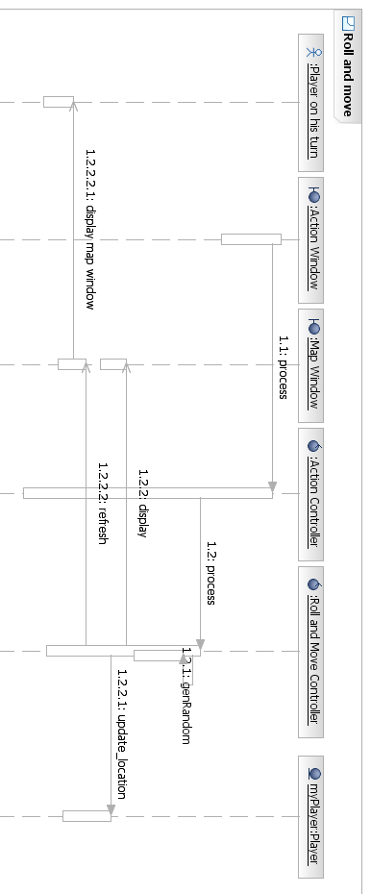
[2] Sequence diagram of Use Case 1(Pay/Receive rent)
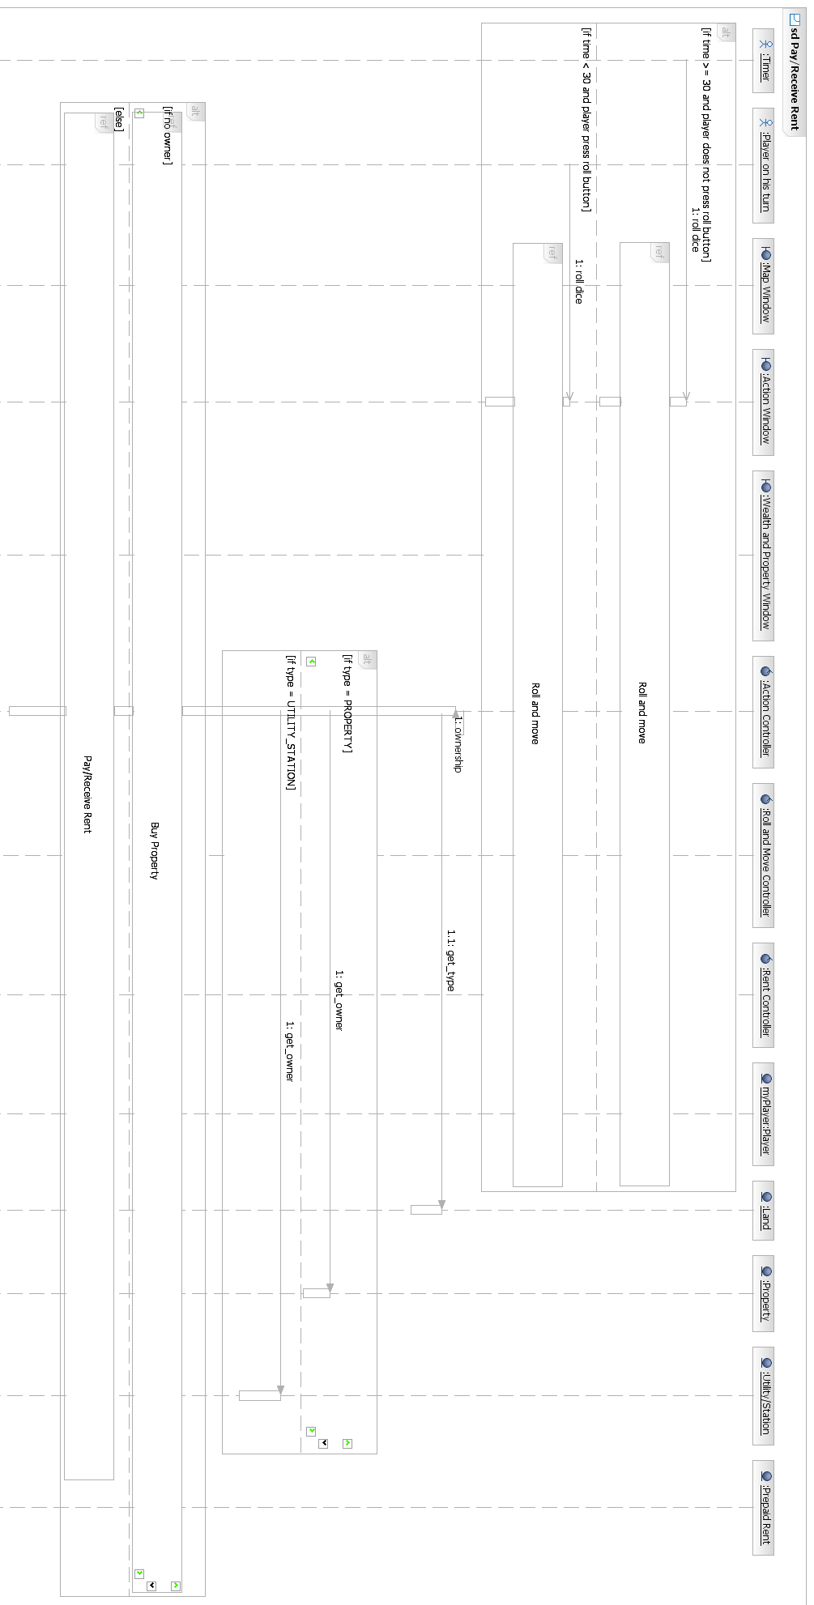
[3] Sequence diagram of Use Case 1(Pay/Receive rent)
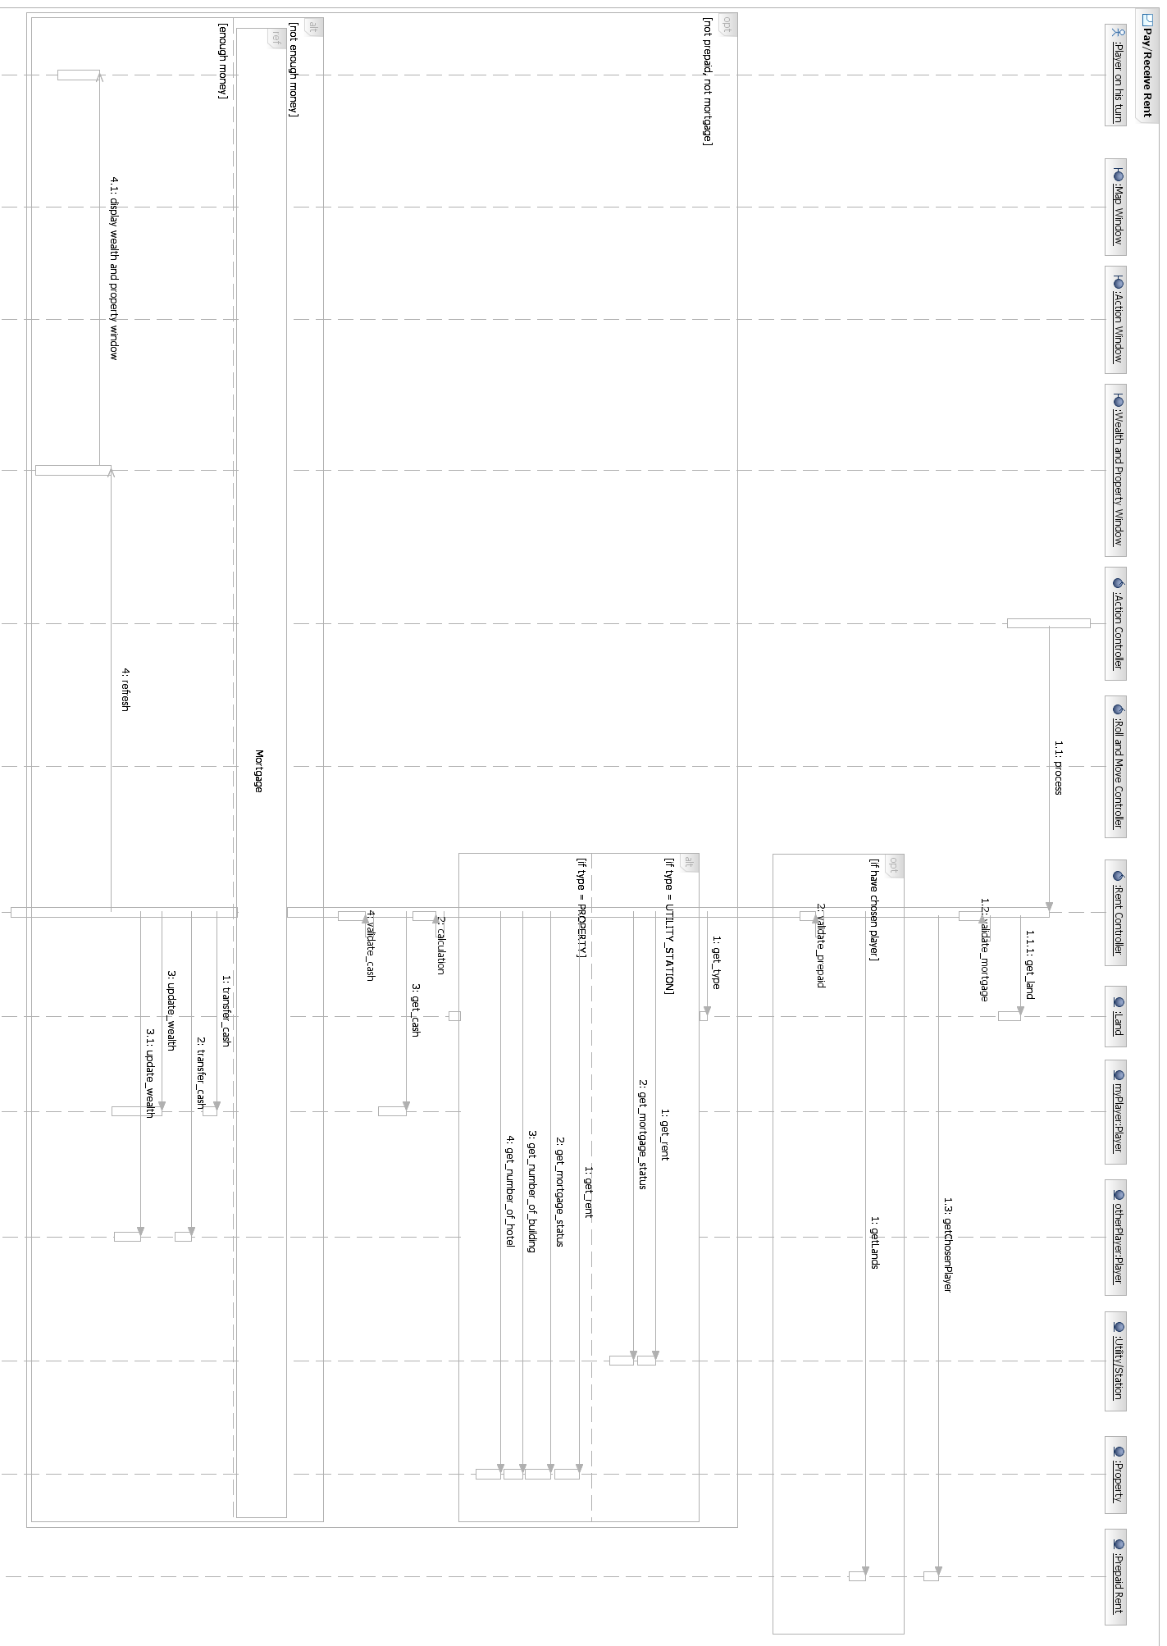
[4] Sequence diagram of Use Case 2(Buy property)
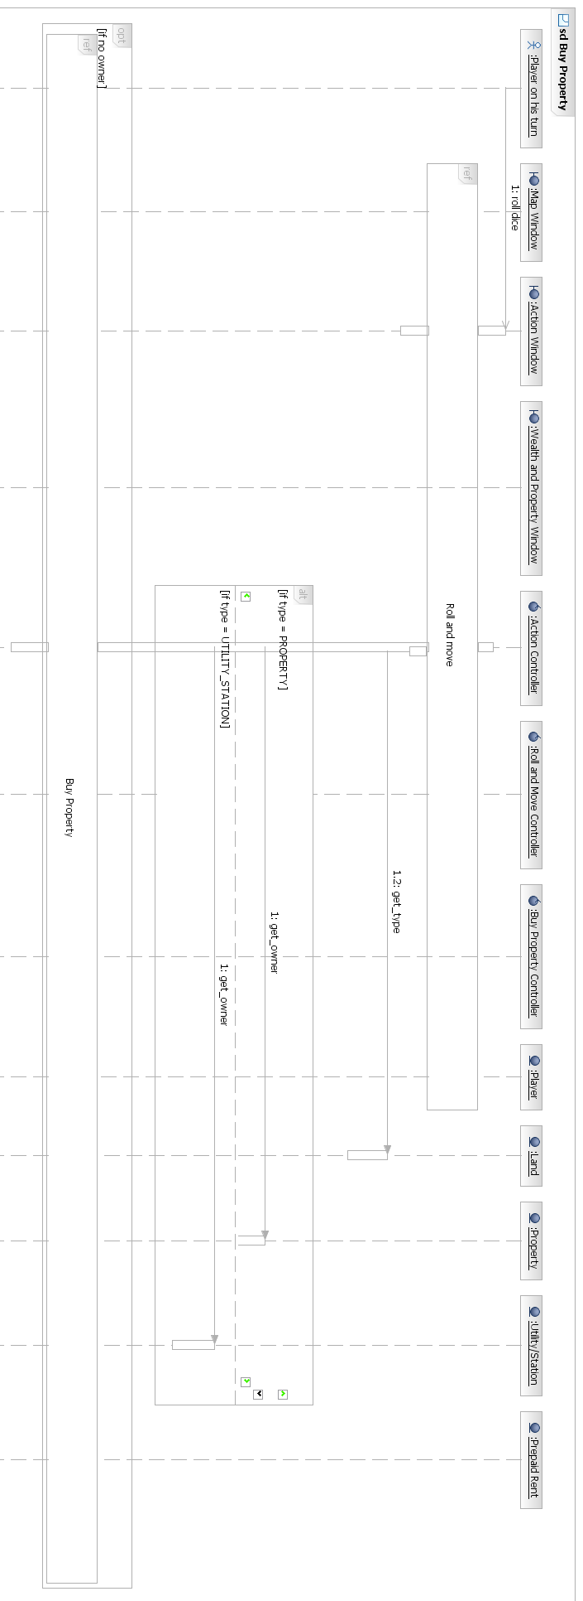
[5] Sequence diagram of Use Case 2(Buy property)
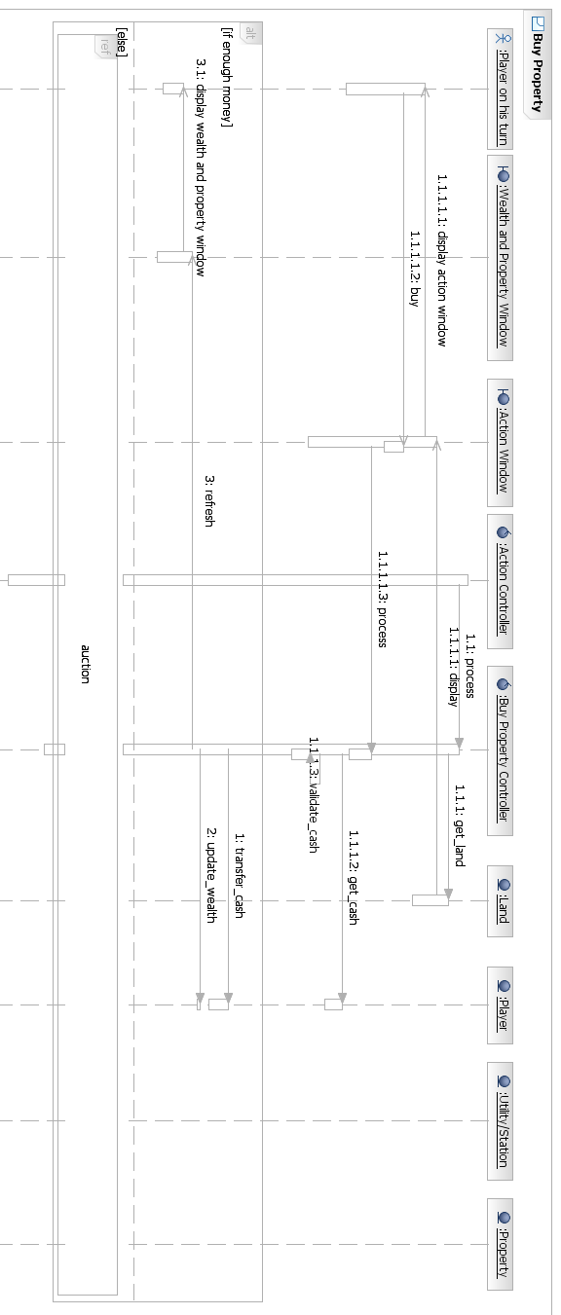
[6] Sequence diagram of Use Case 11(Prepay Rent)
